Beginning the Loan Application Process

If your business is or will be in
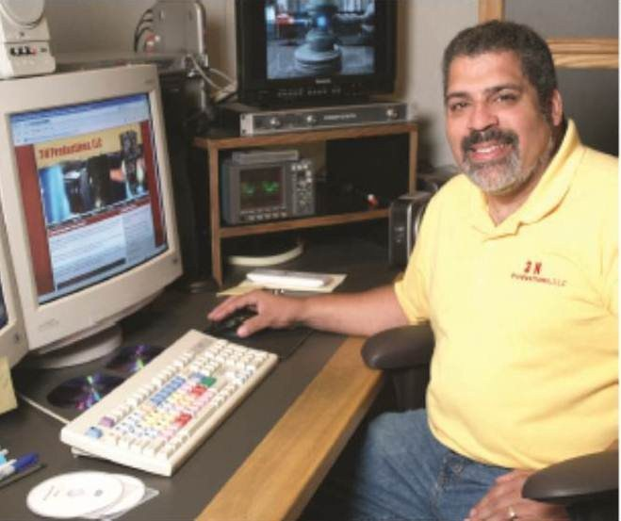
Florence County contact:

Florence County Economic
Development Commission
P.O. Box 410
Florence, WI 54121

Phone: (715) 528-3294
FAX: (715) 528-5071

E-mail: wgehlhoff@co.florence.wi.us
www.exploreflorencecounty.com

If your business is or will be in Marinette County contact:

inVenture North
1320 Main Street
Marinette, WI 54143

Phone: (715) 732-1040
Cell: (715) 927-7008

E-mail: info@inventurenorth.com
www.inventurenorth.com

For additional information contact
NWTC at (920) 498-6995
E-mail: Dean.Stewart@NWTC.EDU

Other Business and
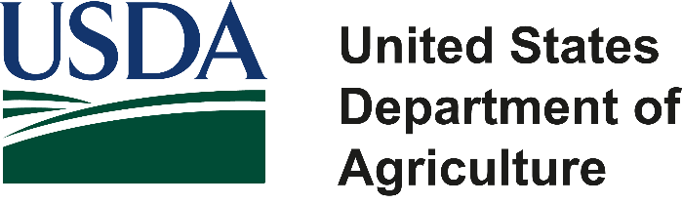
Loan Resources

The GEMSTAR Micro Loan Program, the USDA, and their partnering agencies are equal opportunity providers, employers and lenders.

GEMSTAR
Micro Loan Program

For Small Business Start-Ups
and Existing Business
Expansion
a Partnership Between . . .
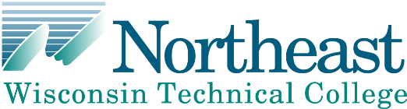

Florence County Economic Development

GEMSTAR
Micro Loan Program

The GemStar Program was established in 2012 with a USDA Rural Development, Rural Business Enterprise Grant to facilitate small business growth and development in Florence and Marinette Counties of Wisconsin.

The purpose of the GEMSTAR Micro Loan Program is to provide access to training and credit for very small businesses not adequately served through the traditional financing system.

Technical Assistance
Loan program applicants must first meet with an NWTC Micro Business Educator to assess their business needs and develop a customized entrepreneurship training plan.

Technical assistance will be accelerated, hands- on and primarily in a one-on-one format. Included in this training will be assistance for developing the business plan and financial projections required to apply for a micro loan.

The client may apply for up to a $10,000 micro loan to accomplish their business start-up or business expansion goals.

Eligible Loan Activities

• Purchase of equipment or fixed assets
• Purchase of furniture and fixtures
• Purchase of inventory
• Other working capital items

Funds cannot be used to refinance debt or for reimbursement of expenditures already made.

Conditions

Loan Amount: From $2,000 up to $10,000 subject to availability of funds.

Interest Rate: Three percent (3%)

Location: Business activities financed must be located within Florence or Marinette Counties during the term of the loan.

Applicant: Must be a small and emerging private business enterprise as defined by USDA Rural Development; a private business employing
50 or fewer new employees and with less than
$1 million in projected gross revenue. Must not
be an officer, employee or board member of FCEDC, MCABI or NWTC. Blood relatives of the same are also ineligible.

Feasibility: Applicants must show the proposed project is viable and there is ability to repay.

Loan Fees: There is a $100 fee for loans from $2,000 to $4,999 and a $200 fee for loans from $5,000 to $10,000, payable at the time of the loan disbursement via check.

Loan Terms: Five years is maximum loan term. Only one micro-loan is allowed per business within a two year period.

Collateral: Will be determined on a case-by-case basis. The loan review committee will seek the best possible collateral position to secure the loan. Personal guarantees and proof of appropriate insurances are required.

Repayment: loan repayments are due monthly. There is no penalty for early loan payoff.
Application Process

Applications may be submitted at any time and will be processed in the order received. Please allow 30-60 days to complete the application process. The application will include:
Balance Sheet & Income Statement for the last three fiscal years for an existing business.

Earnings projections for three (3) years from date of application, assumptions included.

Cash Flow analysis on a monthly basis for the first (1st) year of operation.

List of proposed collateral.

Personal Financial Statement of owners. Resume(s) for the management team.
Signed copies of personal and business Federal Tax Returns for the past three years.

Business Plan and Financing Proposal as developed or reviewed via the NWTC process.

A list of equipment or items to be purchased with loan proceeds.

Loan Review Process

Loan Review Committee: will review application for completeness, eligibility and accuracy. Once all documents and information are reviewed, final approval will be determined by this committee.

Notice of award: After the terms of the loan are finalized, and the loan is approved by the Loan Review Committee, a loan closing date will be scheduled with you.

